## horizontal line

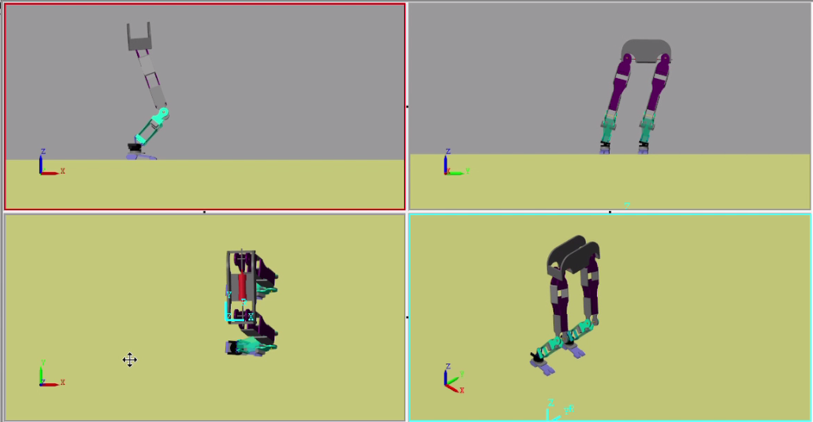

Bravo

10-DOF Bipedal Robot

Venkatesh Prasad, Hari Prashanth, PSVS Sai Kumar, J Nikhil

# 

# Introduction

The project was started in the year 2017 with a long-term goal of developing RMI’s very own humanoid robot. To begin with, we planned to build a bipedal robot capable of walking on plane surface . As the cost estimates were high, we decided to do a software simulation of the robot which would serve the purpose of a testing platform for various mechanisms, gaits and control algorithms.

# Hardware Information

For Pragyan 2018, only the simulation was done.

# Software Information

We used MATLAB’s Simscape Multibody to run our simulations. Simscape Multibody™ (formerly SimMechanics™) provides a multibody simulation environment for 3D mechanical systems, such as robots, vehicle suspensions, construction equipment, and aircraft landing gear.

We designed the robot in PTC Creo and imported the 3D model into SimMechanics. We used the 3D animations provided by SimMechanics to analyse system dynamics.

# Work Done

* We designed the 3D model in PTC Creo. The model has totally 10 degrees of freedom. 2 Degrees of freedom for each hip(sideways and forward), one each(forward) for the knees and 2 each(sideways and forward) for the ankle.
* The model was imported into SimMechanics and a ground surface was modelled for the robot using Contact Forces Library present in MATLAB. Appropriate contact damping and friction were chosen for the ground block.
* Chose 4 contact points at 4 corners of the foot of the robot.
* We implemented static walking gait. In static walking, the robot is stable at all instants of its step. The zero-moment point(ZMP) always stays within the support polygon(SP). The gait is extremely slow as the step size is kept extremely small in order to keep the ZMP within the SP. The criticial points for the angle of the robot where the robot lost stability were determined through trial-and-error. Using these constraints, a trajectory was developed for the robot.
* The robot executed the trajectory without losing stability.

# Future Scope

* We intend to build the robot to execute a static walking trajectory in the coming academic year.
* Following that, we intend to implement the dynamic walking gait in simulation. That would require significantly more sophisticated control algorithms in order to stabilise the robot.
* A dynamic walking robot would be built after that, capable of walking even on uneven surfaces.